**Exercise Questions**

***Question 1:***

Write a C program to read elements in a matrix and check whether matrix is an Identity matrix or not.

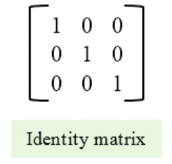

***Question 2:***

Dealing with Matrices is always a fun thing for students. Just for fun, a group of students has decided to play with the matrices and they have thought about a game in which two matrices are involved of **m x n** order. User can provide the values for the matrices and mention the 2 row numbers which they want to interchange the values of. Your task is to make a C program that is able to solve and give the new matrix with interchanged values.

***Question 3:***

Tariq invented a type of matrix during his PhD research called texco's matrix . such a matrix who's sum of both diagonals equals 20 is called texco's matrix. you have to write a program to identify texco's matrix.

***Question 4:***

Use a double-subscripted array to solve the following problem. A company has four salespeople (1 to 4) who sell five different products (1 to 5). Once a day, each salesperson passes in a slip for each different type of product sold. Each slip contains:

a) The salesperson number

b) The product number

c) The total dollar value of that product sold that day

Thus, each salesperson passes in between 0 and 5 sales slips per day. Assume that the information from all of the slips for last month is available. Write a program that will read all this information for

last month’s sales and summarize the total sales by salesperson by product. All totals should be stored in the double-subscripted array sales. After processing all the information for last month, print the results in tabular format with each column representing a particular salesperson and each row representing a particular product. Cross total each row to get the total sales of each product for last month; cross total each column to get the total sales by salesperson for last month. Your tabular printout should include these cross totals to the right of the totaled rows and to the bottom of the totaled columns.

***Question 5:***

Enter the rows and columns on run time put the elements and Find the inverse of matrix matrix it can be 3x3 etc.

